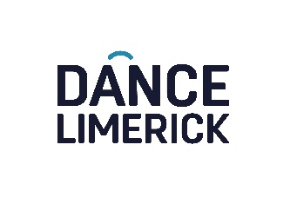
Dance Limerick Percolate Artist Residency Programme 2024
OPEN CALL | Submit your application before 5pm Thursday 28 September 2023.

Become one of our 2024 Percolate Artists
Dance Limerick offers supported residencies to professional dance artists and choreographers to research and develop work in the beautiful surroundings of St. John’s church dance space or studio throughout 2024. The residency aims to support research, experimentation, practice development and/or creation of work. Residencies are open to national and international dance artists in all dance genres and at any stage of their career.
Please apply by completing this form along a copy of your CV & Video Links to 2 recent works (or alternatively if you are making a video application instead please send the video file, maximum length 6 minutes via Westransfer or Dropbox to info@dancelimerick.ie).
Please contact leonor.miralles@dancelimerick.ie if you have any questions, need support or have access requirements we need to meet to support you in making your application. We look forward to hearing from you.

CONTACT INFORMATION
1. Applicant Name:
2. Applicant Surname:
3. Personal Pronouns
4. Email address:
5. Telephone:
6. Website:
7. Social Media Handles:

8. How long do you require studio space? Please check box
☐ 1 week
☐ 2 weeks
☐ 3 weeks (Please demonstrate need in question 9)

9. What dates do you require the studio space? Please indicate if there are specific dates when you would like your residency to take place or if you are flexible.

10. How do you envisage using this residency? (500 words/3 minutes)

11. How might this residency impact your artistic development? (500 words/3 minutes)

12. Do you plan to work with any collaborators during the residency? If so, who? (500 words/3 minutes)

13. Please outline how you will fund aspects of the residency not provided for by Dance Limerick.

Please send the following documents to info@dancelimerick.ie by 5pm Thursday 28 September 2023 to apply for Percolate Artist Residency Programme 2024, Thank You.
- Completed Application Form
- Short CV
- Video Link to 2 recent works

